Quote Entry Restriction

Overview

Current processing
Currently there is no need for this restriction because each user has a unique acronym.

New requirement
Once we allow multiple users with the same acronym to quote, we need to introduce a restriction so that only one userid having a given acronym will be allowed to have a quote in a given class at any time. This restriction shall be dynamically checked, so that if a user who has been quoting a class logs off the system, cancels all his quotes in this class, or all of his quotes in this class get filled, at that time another user with the same acronym can begin quoting this particular class.
If two or more userIds with the same acronym attempt to start quoting the same class, only the userId that enters a quote for this class first will be allowed to do so. The quotes belonging to the other userIds will be rejected

Design

Restricting quote entry
We will implement the quote restriction cache that would return the userId belonging to a given acronym, that entered a valid quote for a given class last. We will call this the currently quoting userId.
The system will perform this lookup for every incoming quote block by acronym/exchange and class. If the returned userId matches the userId from the incoming quote block, the quote block will be allowed to proceed. Otherwise the system would iterate through all the quotes for the given class and belonging to the currently quoting userid and see if they all have bid and ask quantity set to 0. If that is true than the incoming quote will be allowed to proceed. Otherwise it will be rejected.

Avoiding race conditions in handling of the currently quoting userId.
It is possible for 2 userId-s with the same acronym to start quoting at the same time and create a race condition in the scenario below:
- userId1 enters some quotes for the given class and then cancels them.
- userId1 and userId2 share the same acronym/exchange. They both start quoting the given class at the same time.
- userId1 checks the quote restriction cache and inserts userId1 in the cache and proceeds.
- userId2 checks the quote restriction cache, sees userId1 in there and checks if userId1 has any quotes in the class. But userId1’s quotes have not been processed yet. So the userId2 is allowed to procede as well.

To fix this we will introduce last access timestamp. This field would hold the last time the userID entered a valid quote.
So with this, the scenario above is modified as follows:
- userId1 enters some quotes for the given class and then cancels them.
- userId1 and userId2 share the same acronym/exchange. They both start quoting the given class at the same time.
- userId1 checks the quote restriction cache, inserts userId1 and sets the last access timestamp in the cache and proceeds.
- userId2 checks the quote restriction cache, sees userId1 in there. It then examines the last access timestamp. If the time passed since userid1 hit the cache is less then predetermined number of milliseconds, userid2 will not be allowed to proceed. This will give userid1 enough time to process/update his quotes.

In addition to the above scenario to improve performance in certain cases, the last access timestamp will also be set whenever userId2 checks the quote restriction cache and finds that userId1 is the currently quoting userId for the class and then proceeds to check all the quotes for userId1 to see if they all have bid and ask equal to 0. This way if userid2 chooses to send another quote for this class within let’s say 5000ms (or whatever this limit will be set to), we would not have to iterate through userId1’s quotes again.

3. QuoteRestrictionManager Design

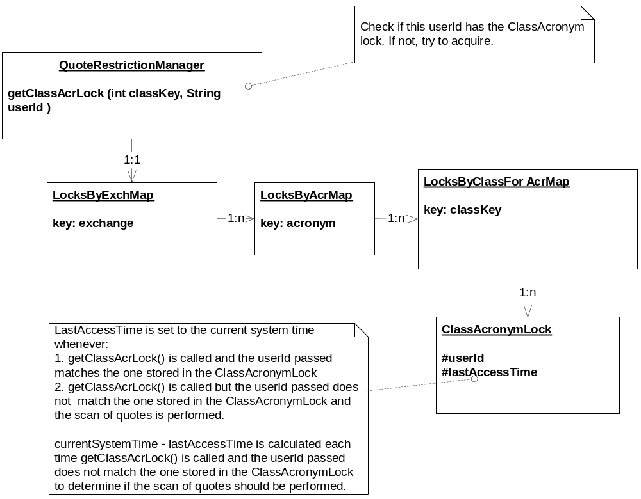

Scripts
- ar command to print a userId of the user currently quoting a class for a given acronym.
- ar command to manually reset the userId of the user currently quoting a class for a given acronym

Database
- None

SetContext
- None

XML/DTD
- MarketMakerQuoteService.xml :
<minClassAcrLockHoldTime>5000</ minClassAcrLockHoldTime >
The userId assigned as the currently quoting userId for a given acronym and product class will be valid for at least this many milliseconds, after last set or last checked. So if another userId tries to quote within this time, the system will not iterate trough the other users quotes but it will reject these new quotes.

Homes/Services
- None

ImplPlan
- This change has to be rolled out before 2 userids with the same acronym can be created.

PerformanceTestingProcedure
- Run Standard set of quote rate tests for single-class and multi-class.
- Run the same tests as above with additional userIds trying to quote the same class as another user with the same acronym.
- Run some quote traffic in ONE_MAIN session, then perform failover and measure the time it takes to rebuild the quote restriction cache.

TestingProcedure

- Test:
  - Setup 2 userIds with the same acronym: userId1 and userId2.
  - Enter a quote for userId1 and product class PC1.
  - Enter a quote for userId2 for class PC1. This quote should be rejected with NotAcceptedAcception error code = OTHER_USER_FOR_ACR_QUOTING_CLASS
  - Enter a quote for userId2 class PC2. This quote should be accepted.
  - Cancel the quote for userId1. Wait for some time (this time should be longer than the value of minClassAcrLockHoldTime in MarketMakerQuoteService.xml) then enter a quote for userId2 for class PC1. This quote should be accepted.
  - Immediately enter a quote for userId1 for class PC1. This quote should be rejected with NotAcceptedAcception error code = OTHER_USER_FOR_ACR_QUOTING_CLASS.
  - Enter a quote for userId1 for a different class. This quote should be accepted.

OperatorProcedure
- No changes

Fallback/Failover
- The quote restriction maps will have to be rebuilt on failover. This is because quotes in ONE_MAIN and CFE_MAIN are persisted and are not canceled on failover.

